1. Create a virtual network with 2 subnets. Each subnet should have 16 Ips only.

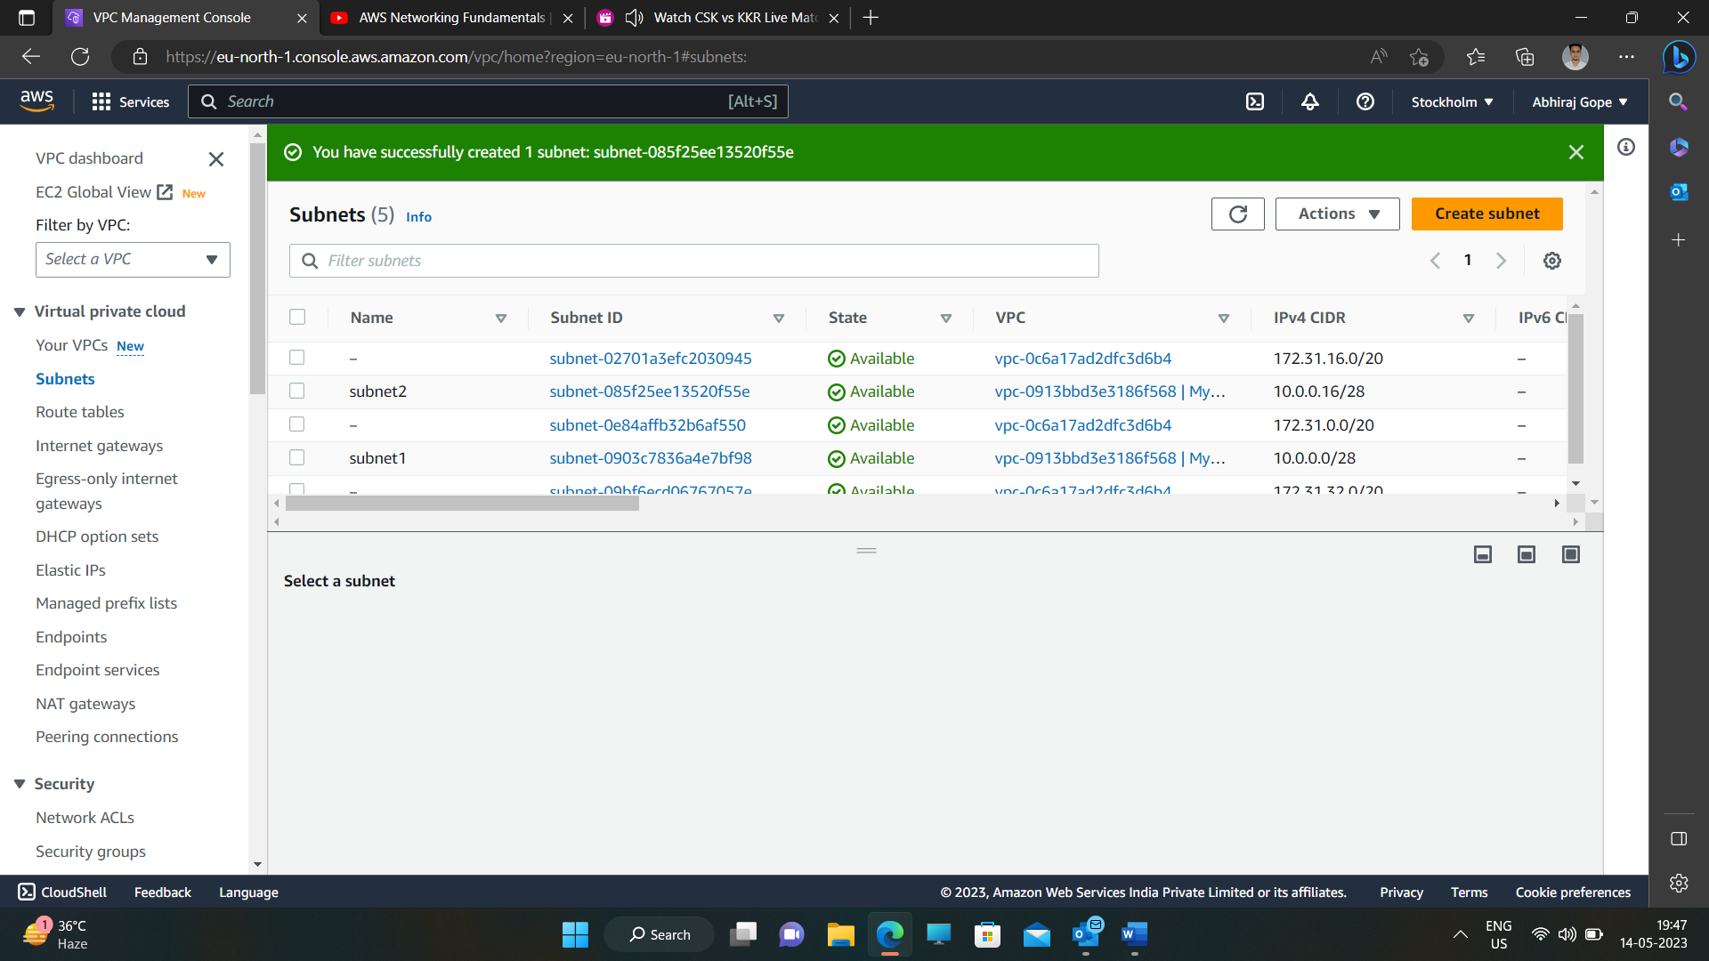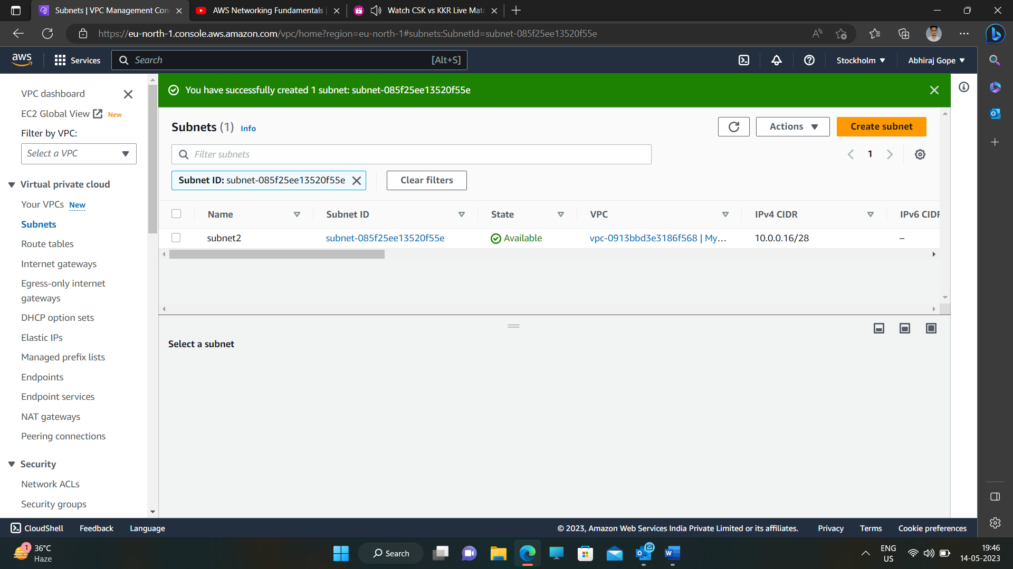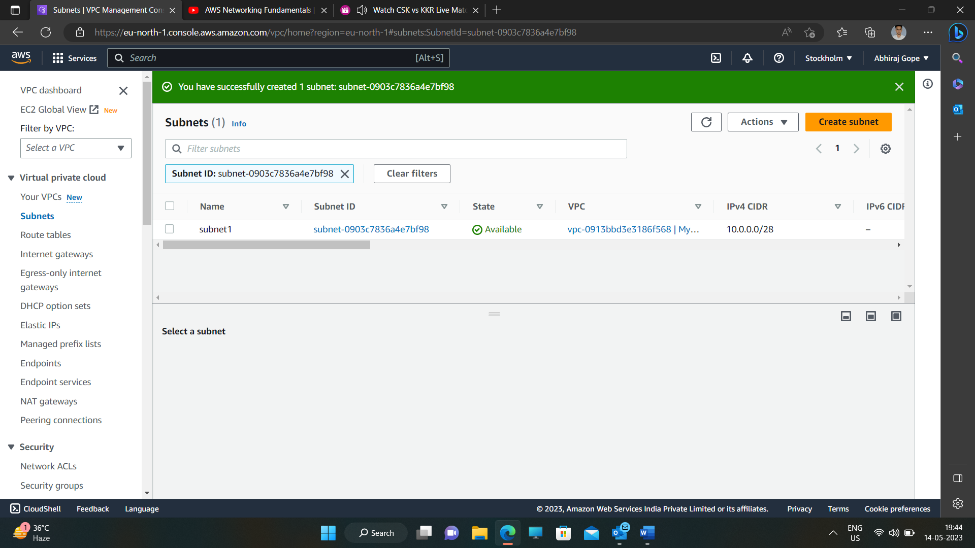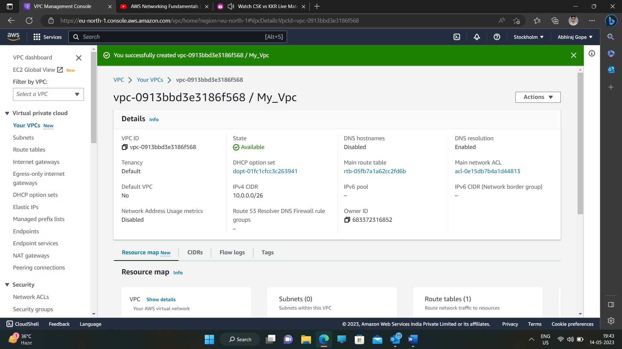

4) Create a Lambda that should trigger as soon as you upload a file in the S3 bucket.

Function should be able to print the name of the file uploaded in the function.

